**Money Flow Index**

The money flow index (MFI) is a momentum indicator that measures the inflow and outflow of money into and out of a security over a specific period of time. The MFI uses a stock’s price and volume to measure trading pressure i.e. buying and selling pressure. Calculate the MFI over a sliding window of a number of days using given conditions and formulae.

Calculate the MFI value plots a line on the chart that oscillates between 0 and 100 levels. When a stock’s price rises, the MFI rises as a sign of increased buying pressure. Inversely, if the stock price drops, the Money flow index will decline as a sign of selling pressure. We can easily predict the directional momentum in the market by keeping an eye on the MFI.

**The MFI is defined as** :

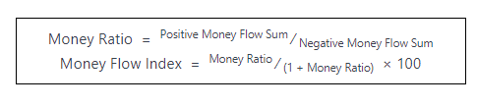

The Money Flow on a specified day is defined as the product of Typical Price and Volume on that day. The Typical Price is defined as:

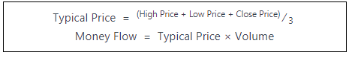

The Money Flow is divided into Positive and Negative Money Flow. On any given day,

* Positive Money Flow: The Typical Price is higher than the previous day’s typical price. The Positive Money Flow is the sum of all the Positive Money Flow over a sliding window of n days.
* Negative Money Flow: The Typical Price is lower than the previous day’s typical price. The Negative Money Flow is the sum of all the Negative Money Flow over a sliding window of n days.
* If the Typical Price is unchanged then that day’s data is discarded.

Given that the stock price data that consists of open, close, low and high price, calculate the Money Flow Index for each day over a sliding window of n days. The first Money Flow Index value is calculated for the (n+1)th day.

**Function Description:**

Complete the ***moneyFlowIndex*** function below. The function must create a file money_flow_index_*n*.csv where *n* is replaced with the given value *n,* that contains the headers: Day, Open, High, Low, Close, Volume, Typical Price, Positive Money Flow, Negative Money Flow, and Money Flow Index as described in the examples above. The money flow index should be calculated over a sliding window of *n* days. No return value is expected.

***moneyFlowIndex*** has two parameters:

*filename*: a string that describes the name of the CSV file containing the headers: Day, Open, High, Low, Close and Volume.

*n*: an integer

**Evaluation**:

The output file must meet the following conditions:

The output CSV file must contain the headers in the given order: Day, Open, High, Low, Close, Volume, Typical Price, Positive Money Flow, Negative Money Flow, Positive Money Flow Sum, Negative Money Flow Sum, and Money Flow Index.

The Day, Open, High, Low, Close, and Volume must exactly match the values given in the input CSV file.

The Typical Price, Positive Money Flow, Negative Money Flow, Positive Money Flow Sum, Negative Money Flow Sum, and Money Flow Index should not have an absolute error more than 

**Constraints**:

* The value of n is such that it is possible to calculate the money flow index over n days.
* The value of n is distinct in all the test cases.

Sample Input:

sample.csv  
10

Sample Output:

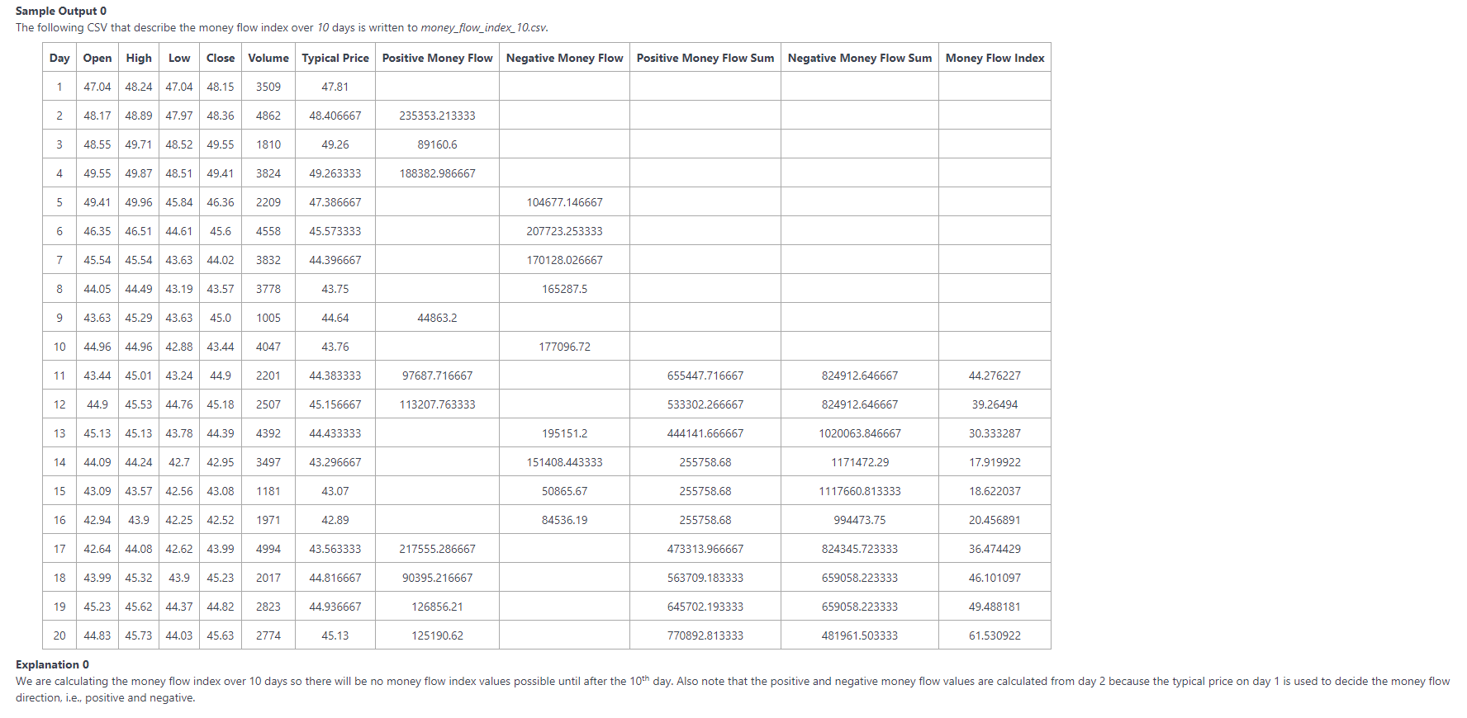

Sample Input 2:

sample.csv  
14

Sample Output 2:

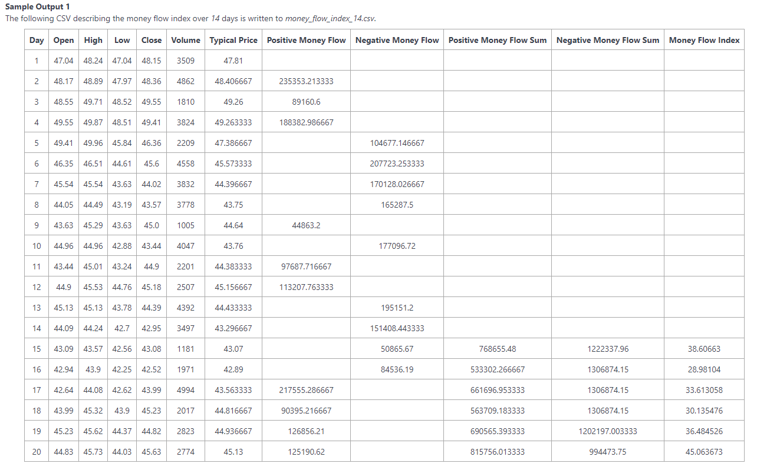

Sample Input 3:

sample.csv  
16

Sample Output 3:

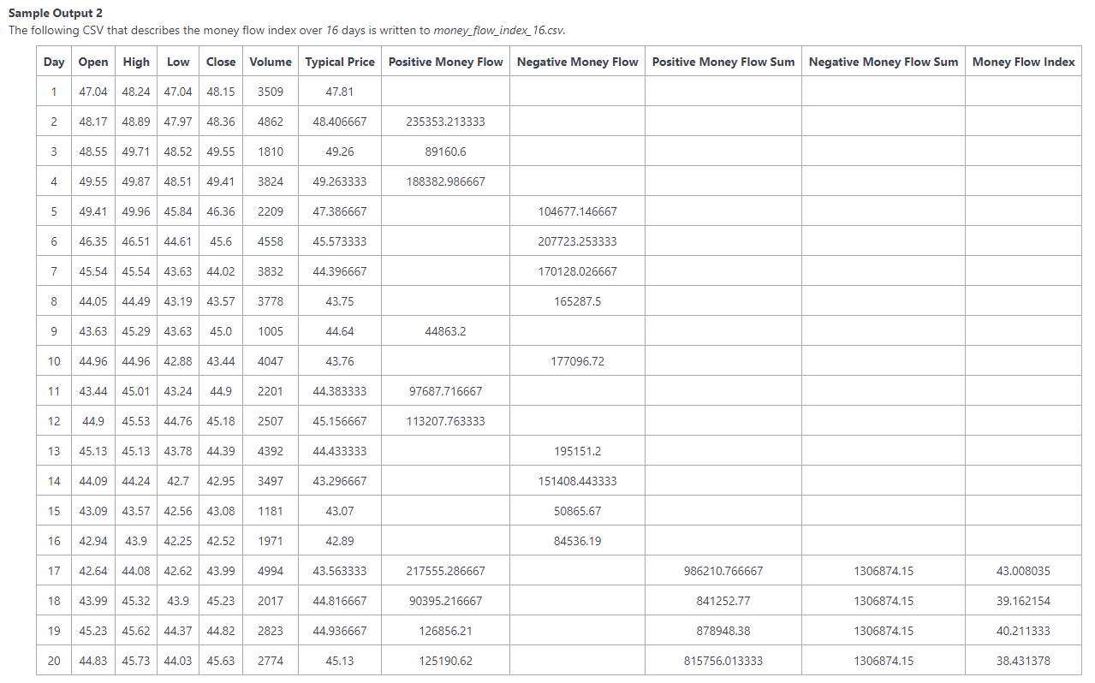

Final Code:

#!/bin/python3

import math

import os

import random

import re

import sys

sn

# Complete the moneyFlowIndex function below.

def moneyFlowIndex(filename, n):

if __name__ == '__main__':